Code first approach in mvc
Tutorial: Code First Approach in ASP.NET Core MVC with EF | by Alpesh Patel | .Net Programming | Medium
Code first is a technique which helps us to create a database, migrate and maintain the database and its tables from the code. From the code, means that you directly maintain the database and its corresponding tables from the .NET Code. It is helpful when you don’t have a database ready and you want to start working with new fresh project and want to create a database and maintain the database directly from your code.
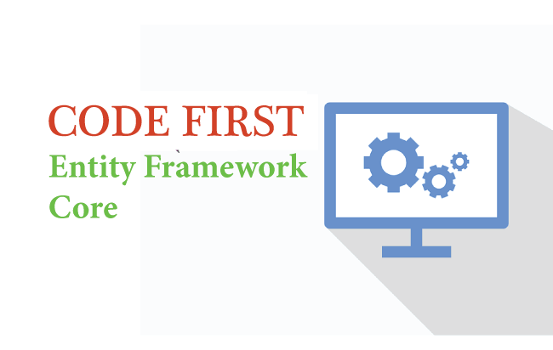
This tutorial will help you to understand what the Code First approach is and how we can achieve it in ASP.NET Core MVC applications using Entity Framework Core migration. Migration always helps us to create, update and sync the database with your model classes. In this demonstration, we will understand the Entity Framework Core migration step by step practically. So, let’s create a new application for the demonstration.
Here is the source code of the entire implementation.
https://github.com/techstrem/Code-First-Approach-in-ASP.NET-Core-MVC-with-EF

Prerequisites
The following must be installed in your system:
- Visual Studio 2019 16.4 or later with the ASP.NET and web development workload

- .NET Core 3.1 SDK or later

Step 1 New Project
Once you have installed the Visual Studio 2019 and .Net Core 3.1 SDK, you can start building a new ASP.NET Core Application.
- Open VS2019
Press enter or click to view image in full size
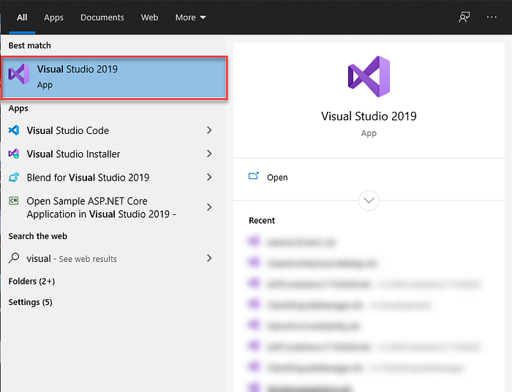
- On the start page, choose Create a new project.
Press enter or click to view image in full size
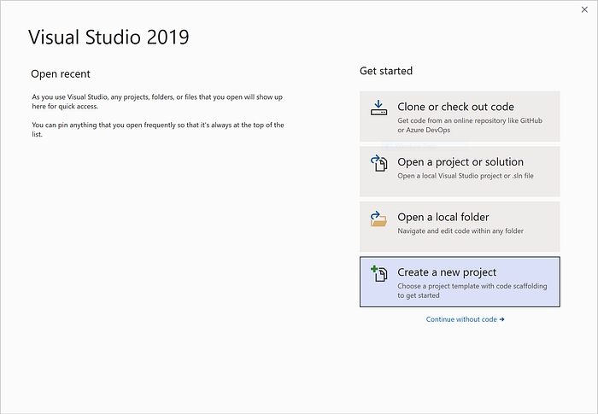
- Create a web app and From the Visual Studio select Create a new project. Select ASP.NET Core Web Application > Next.
Press enter or click to view image in full size
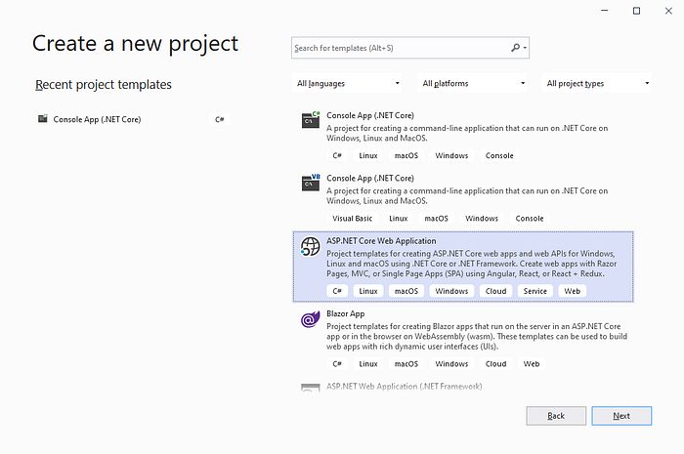
- Give your project a name i.e. SampleCodeFirstInDotNETCoreMVC and give your project a location where it’ll be saved and click Create.
Press enter or click to view image in full size
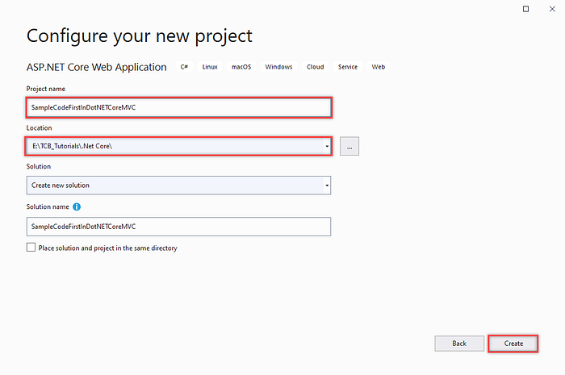
- Now, you need to choose the framework version and MVC project Template (Web Application Mode — View — Controller):
Press enter or click to view image in full size
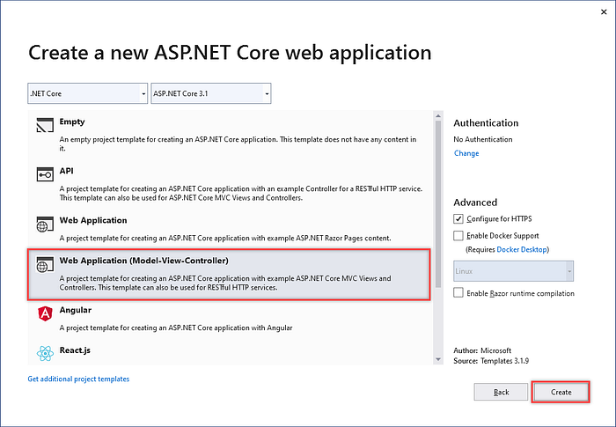

Step 2: Install the NuGet Packages
We will install some of the required Entity Framework Core packages from the NuGet Package Manager for performing database operations from the code.
- From the Solution right click on dependency, select Manage NuGet Packages and Select the Browse tab, and then enter Microsoft.EntityFrameworkCore.SqlServer in the search box, select Latest Stable Version and Install.
Press enter or click to view image in full size
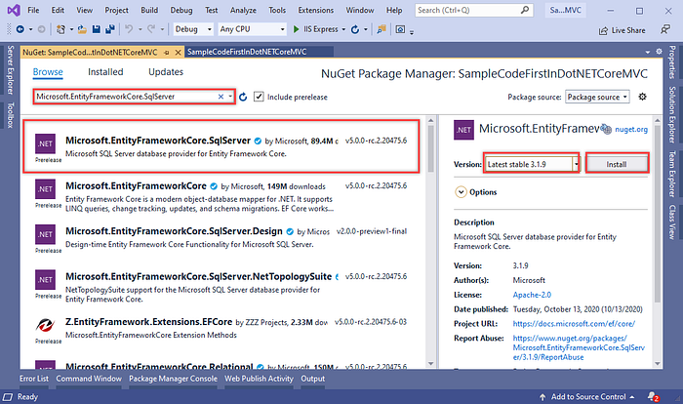
- Now, install Microsoft.EntityFrameworkCore.Tools as same as above steps.
Press enter or click to view image in full size
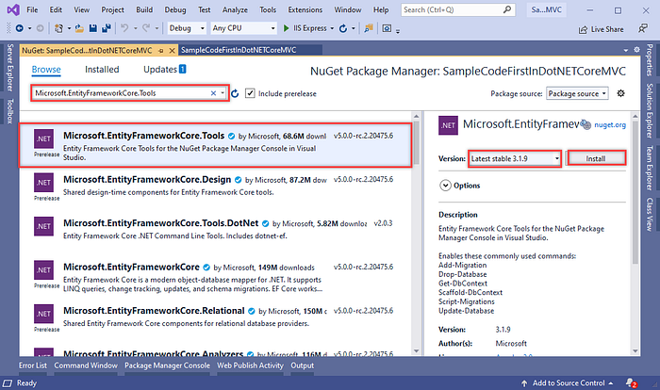

Step 3: Create Model and Context Classes:
- Now, Add new class with name “TodoItem”, using Right-click the Models folder and select Add Class.
Press enter or click to view image in full size
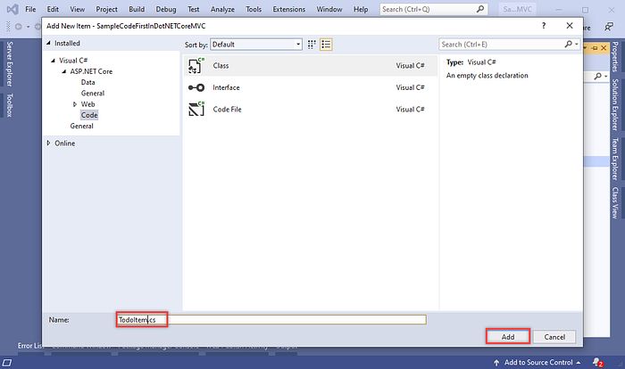
- Replace the template code with the following code:
Press enter or click to view image in full size
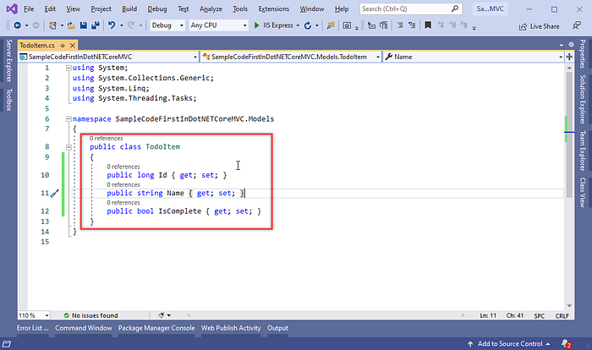
- Now it is ready for add database context:
Right-click the Models folder and select Add > Class. Name the class TodoContext and click Add and change code in TodoContext.cs as following:
Press enter or click to view image in full size
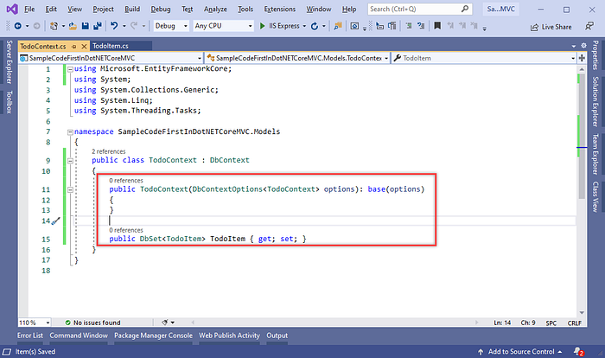
- We first write the code, which means Model classes, and on the basis of these classes our tables are auto-generated inside the database. However, to create these tables in the database we have to define our connection string where we will define our server and database name.
- Connection string you need to write inside the appsetting.json file as follows:
Press enter or click to view image in full size
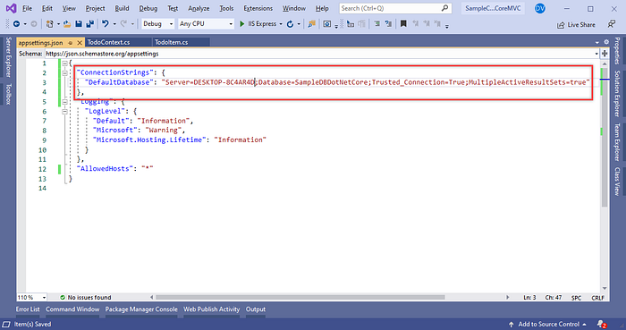
- In ASP.NET Core, services such as the DB context must be registered with the dependency injection container. The container provides the service to controllers.
- Update Startup.cs with the following highlighted code:
Press enter or click to view image in full size
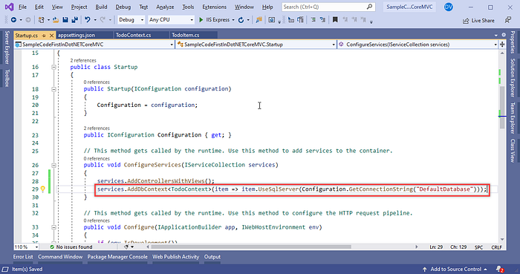

Step 4: Create Database using Migration:
- Open Package Manager Console from the Tools Menu and select the Default project for which you would like to generate migrations code. For this demonstration, we have only a single project as CRUDOperationASPDotNETMVCEFCore. Therefore, by default, it is a default project.
- For creating the migration code, we use ‘add-migration MigrationName’ command. So, let’s perform this operation and see what happens. Therefore, in the Package Manager Console, just type ‘add-migration initialmigration’ command and press Enter.
Press enter or click to view image in full size
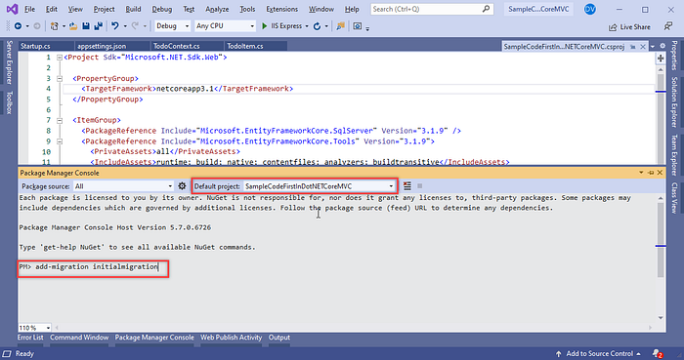
- After the add migration command executes successfully, it creates a folder name as ‘Migration’ in the project and creates the class with the same name [MigrationName] as we have provided while executing add migration command with some name. Here you can see the table structure based on your Model (TodoItem), which is ready to generate the database.
Press enter or click to view image in full size
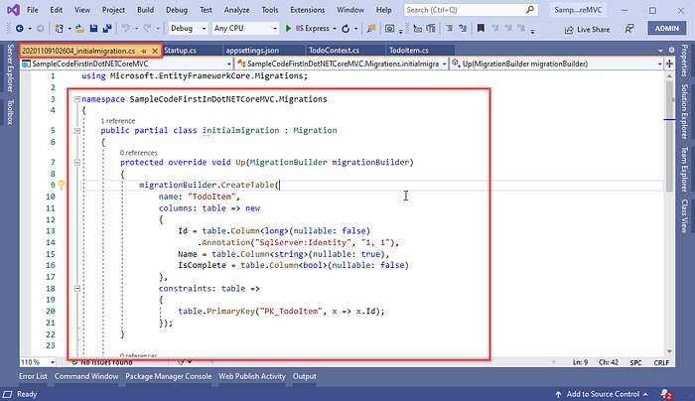
- We have only created the migration script which is responsible for creating the database and its table. But we’ve not created the actual database and tables. So, let’s execute the migration script and generate the database and tables. Therefore, executing the migration scripts we have to execute ‘update-database’ command.
Press enter or click to view image in full size
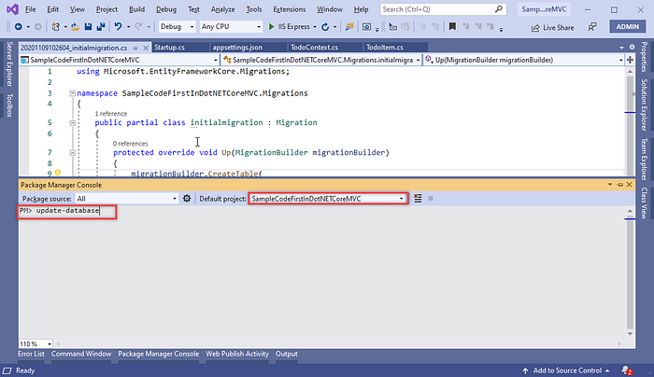
- After the add update-database command executes successfully, you will received message for “Done” and you can see you database also created on SQL server.
Press enter or click to view image in full size
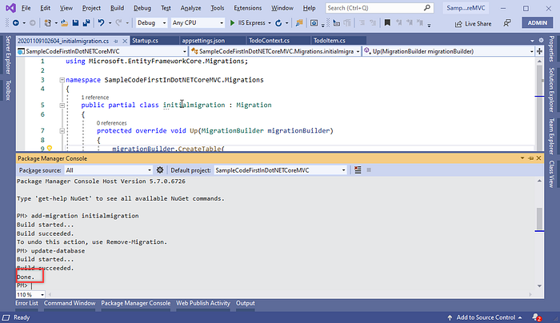
- We just need to go to SQL Server Management Studio and login and see the Database. You will find the database, table and Entity Framework Migration history table as follows.
Press enter or click to view image in full size
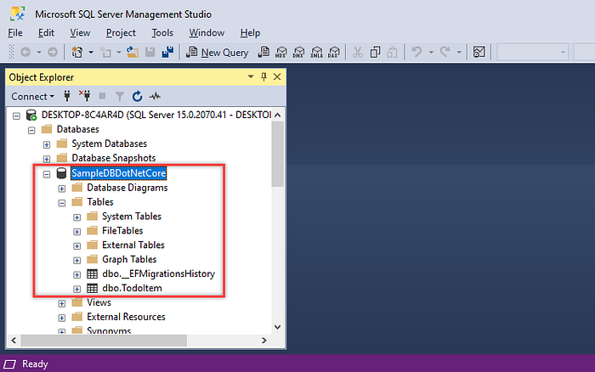

Step 5: Update Database using Migration:
- Now, let’s modify the TodoItem model and add a new property as Description with string type as follows.
Press enter or click to view image in full size
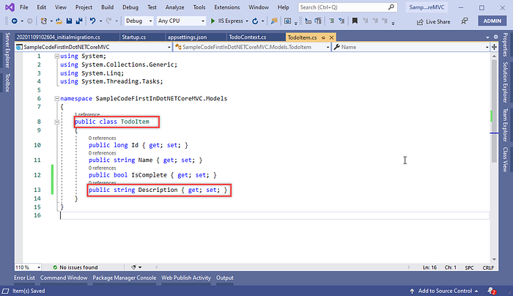
- Again we need run migration command and as follow, Move to package manager console and run the following command to add migration, this time we have given the name of migration as ‘addedDescription’ this is just example you can enter any name.
Press enter or click to view image in full size
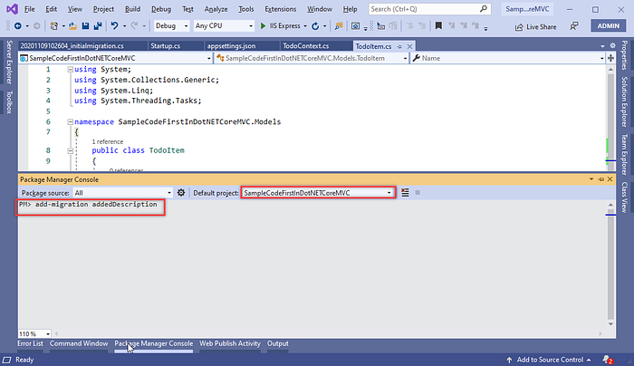
- Once the migration command execution will be completed, it will create a new class for migration name as follows and you can see your changes on this migration class:
Press enter or click to view image in full size
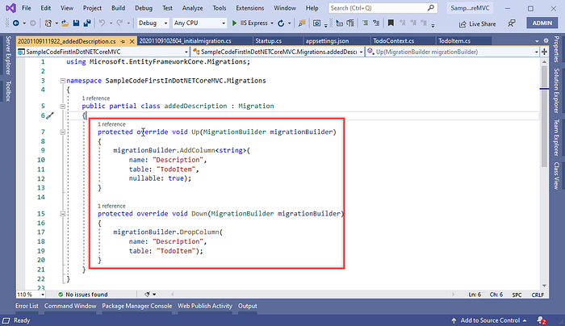
- For updating the table in the database with the new column as Description, we have to run following command for updating the database.
Press enter or click to view image in full size
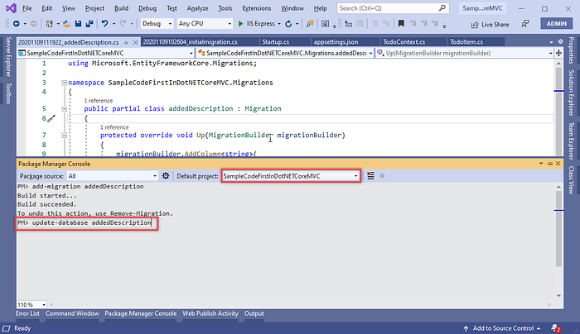
Press enter or click to view image in full size
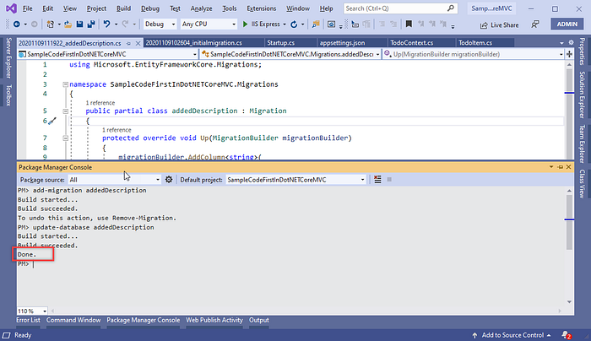
- After done update database command will execute successfully, just check the database’s table. You will find the new column has been added to the TodoItem table as description.
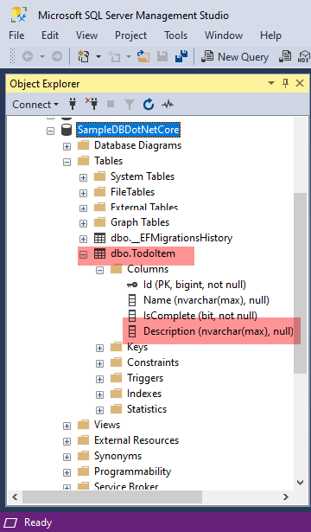

Step 6: Seed dummy data on table from code side:
- Now, let’s see learn how we can seed some dummy data into the table. Open EmployeeDbContext class and override the DbContext method ‘OnModelCreating’. Using the help of the ModelBuilder, Add some dummy data for the TodoItem table as follows.
Press enter or click to view image in full size
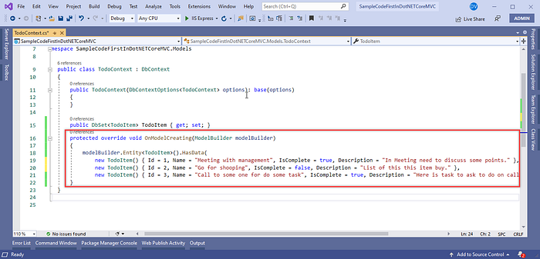
- Let’s add it to migration using the following command.
Press enter or click to view image in full size
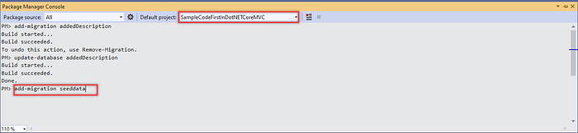
- After run migration command will execute successfully, we can see the following seeddata class will be generated with insert data configuration.
Press enter or click to view image in full size
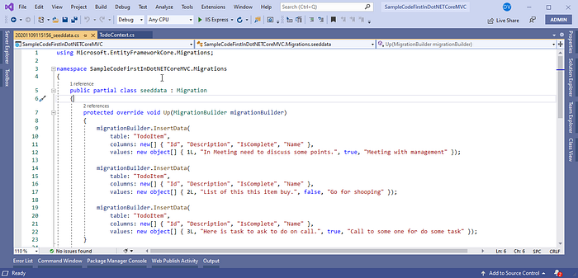
- Let’s update the database with generated migration class using the following command.
Press enter or click to view image in full size
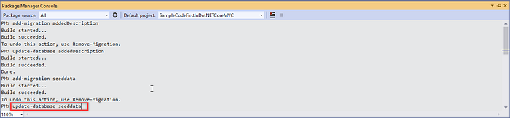
- Once run command will execute successfully in Package Manager Console, just move to the database and run select query for the table. You will find the same dummy data which we have defined in migration has been updated into the table.
Press enter or click to view image in full size
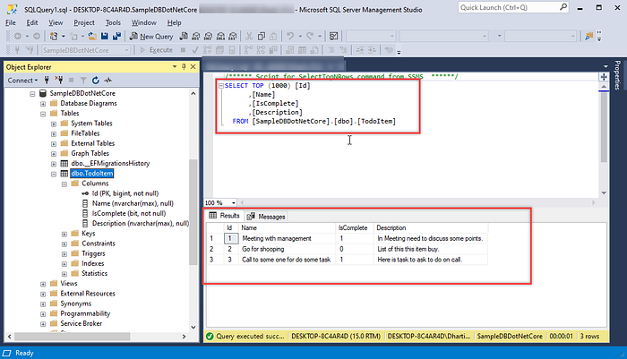

Thanks You…!

